**Experiment No.5 Date:12/10/2021**

Transients in RC Circuits

**Objective:**

To Study the transient phenomenon in series RC Circuit.

**Application:**

1. RC circuit can be used to provide time delays. The warning blinkers usually found on road construction sites is an example. An electronic photoflash unit is another common example. ***It exploits the ability of the capacitor to oppose any abrupt change in voltage***

**Simulation Tool:**

LTSpice – transient analysis

**Switching Phenomenon in Circuits:**

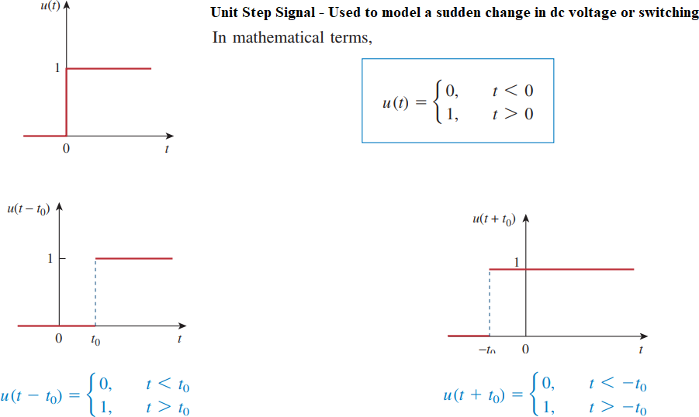

**Step Response of a RC Circuit**

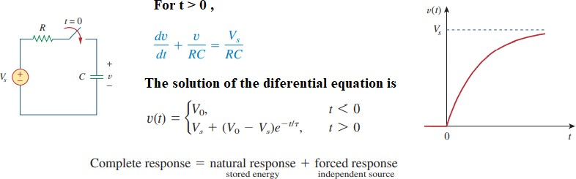

**Step Input – Modelled as Switch**

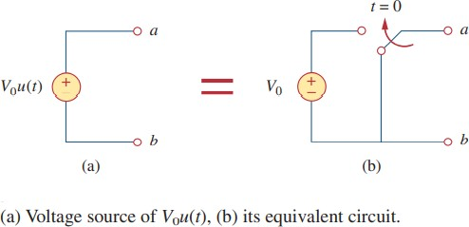

**Simulation Circuits:**

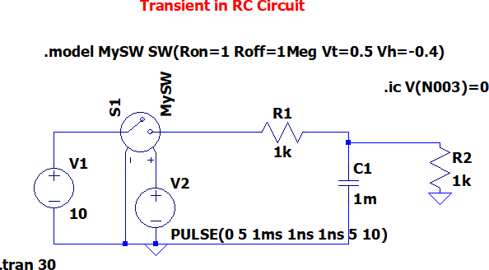

Observe the step response of both the circuits with input being the step voltage, and output is the voltage across the capacitor.

Ref: (Voltage Controlled Switches)

[https://www.analog.com/en/technical-articles/ltspiceiv-voltage-controlled-switches.html](http://www.analog.com/en/technical-articles/ltspiceiv-voltage-controlled-switches.html)

1. **R1 = 500Ω, C1 = 5µ**

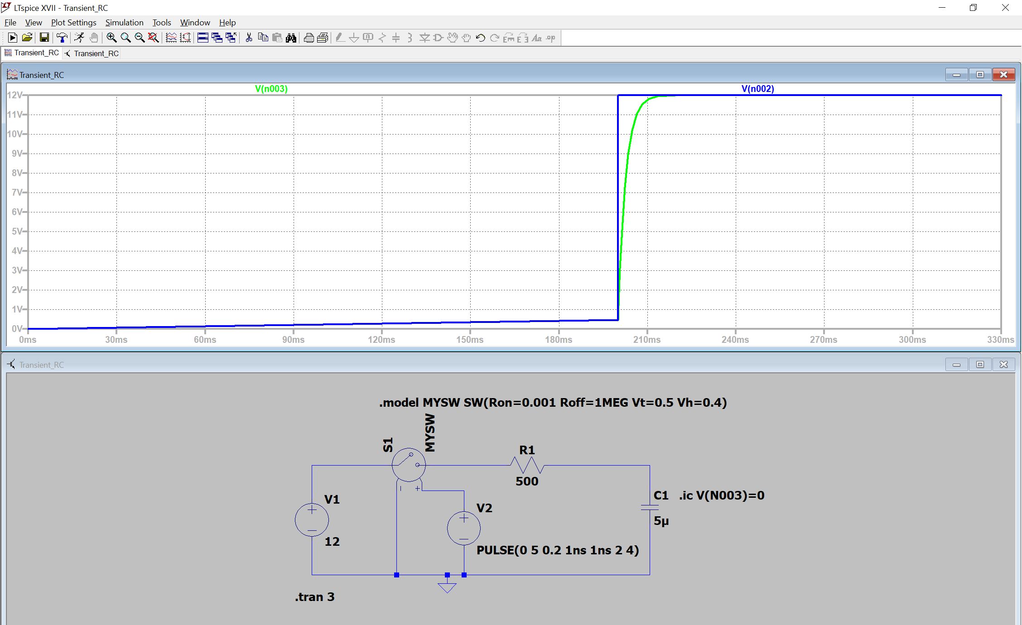

1. **R1 = 1kΩ, C1 = 5µ**

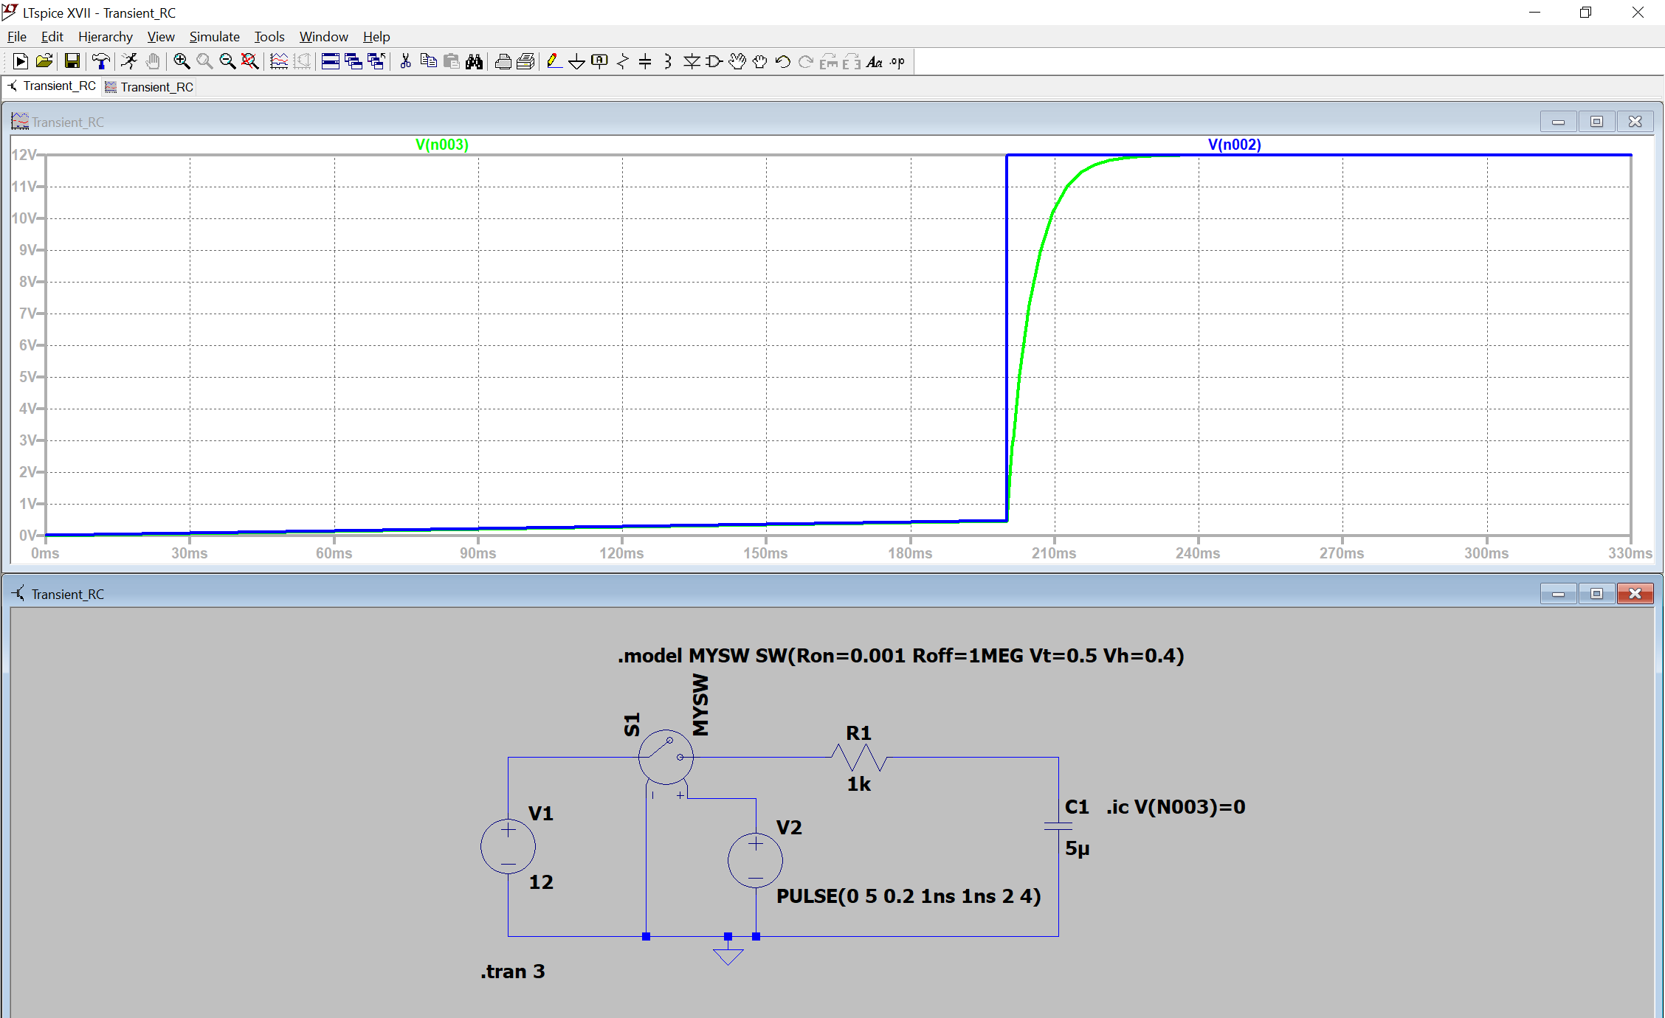

1. **R1 = 10kΩ, C1 = 5µ**

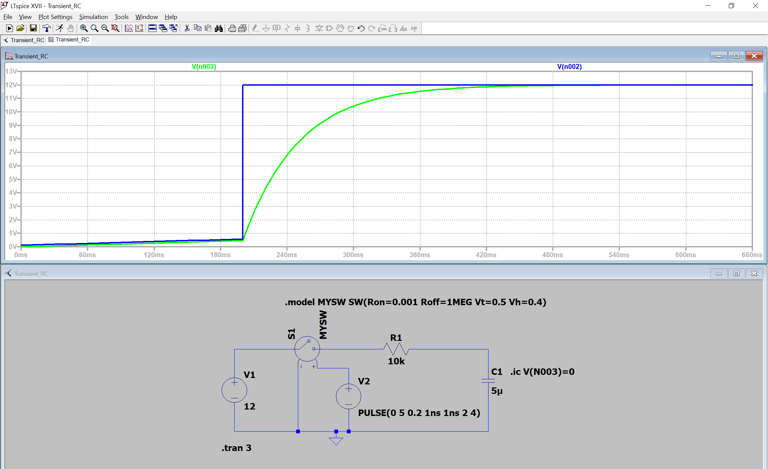

1. 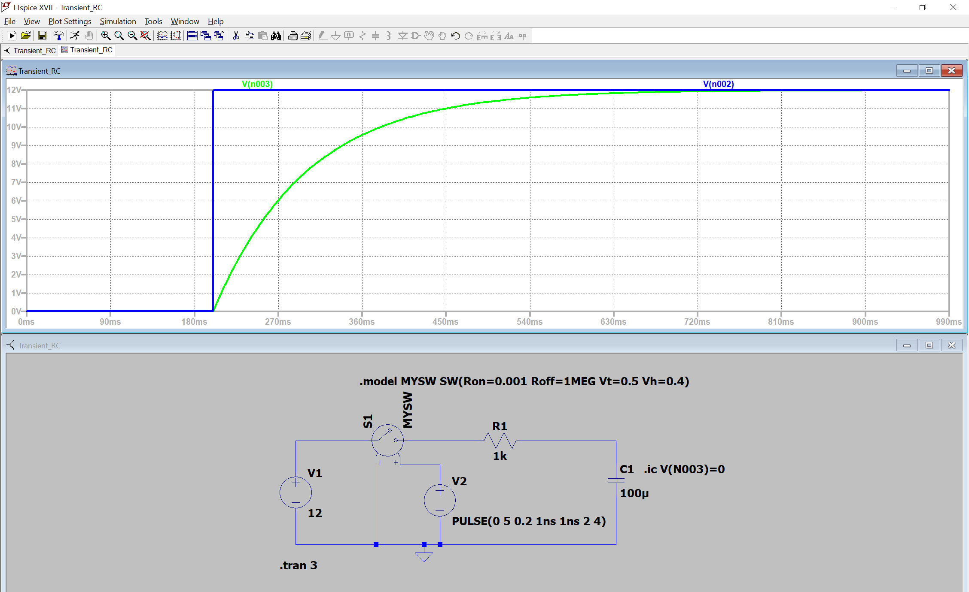**R1 = 1kΩ, C1 = 100**